

MET’s Institute of Technology (Polytechnic), Nashik Department of Information Technology (NBA Accredited) www.metbhujbalknowledgecity.ac.in
MAHARASHTRA STATE BOARD OF TECHNICAL
EDUCATION –MUMBAI
A

Capstone Project Report on

“Nashik Sangam”

Submitted by,
Sneha Sanjay Gaikwad Hemalata Dattatray Chaure
Tanuja Dnyaneshwar Kadam

Guided by,

Mr. S.B. Patil Sir
Head of Department of
Information Technology

Academic Year 2025-26

MET’S INSTITUTE OF TECHNOLOGY POLYTECHNIC BHUJBAL KNOWLEDGE
CITY, ADGAON, NASHIK


MET’s Institute of Technology (Polytechnic), Nashik Department of Information Technology (NBA Accredited) www.metbhujbalknowledgecity.ac.in

CERTIFICATE
This is to Certify that this report on,
“Nashik Sangam”

Submitted by,

Sneha Sanjay Gaikwad Hemalata Dattatray Chaure
Tanuja Dnyaneshwar Kadam

The students of 3rd year Information Technology Department In 2025-26 As a part of Project work prescribed by
The Maharashtra State Board of Technical Education, Mumbai I have guided them for the Project work from time to time
Also, I found them satisfactorily progressive.
And the said work has been assessed by me and I am satisfied that the same is up to the standard envisaged for the level of the course.

Mr. S. B. Patil Dr. R.S. Narkhede Project Guide & Head of Department Principal

Mr. S.R. Gaidhani
(Language Editor) (External Examiner)

MET’s Institute of Technology (Polytechnic), Nashik Department of Information Technology (NBA Accredited) www.metbhujbalknowledgecity.ac.in
.

Vision Statement of MET’S Institute of Technology - Polytechnic

To give emphasis and focus on the development of competent technocrats to accept need based challenges with a sense of social responsibility.
Mission Statement of MET’S Institute of Technology - Polytechnic

M1 : To incorporate the educational program from basic engineering to emerging trends M2: To establish standards of education to meet requirements of Technology and Industry. M3: To make continuous efforts to inculcate the sense of social responsibility among student

Vision Statement of Department of Information Technology

To develop competent IT engineers with enhanced knowledge, skills and professional attitudes to suit the changing scenario and to serve techno-social needs.

Mission Statement of Department of Information Technology

M1 : To implement teaching-learning processes for the spreading the knowledge fundamental engineering and emerging trends .
M2 : To adapt teaching practices to meet the needs of the IT industry and society.
M3 : To inculcate the sense of social responsibility among learners.

Acknowledgement
We take this opportunity to express our deepest sense of gratitude and sincere thanks to all those who have directly or indirectly helped us in the successful completion of our project titled “Image Reality” during the academic year 2025–2026, as a part of the Diploma in Information Technology at MET’s Institute of Technology – Polytechnic, Bhujbal Knowledge City, Adgaon, Nashik.
We are heartily thankful to Rich System Solutions, Nashik, for providing us with industrial sponsorship, valuable guidance, and first-hand exposure to real-time industrial practices and the professional working environment. This industrial experience has helped us enhance our technical knowledge and practical skills. We would like to express our sincere gratitude to Ms. Gauri Nandkumar Joshi, Director, Rich System Solutions, for her valuable guidance, encouragement, and support, which helped us improve the project in many ways.
We express our sincere thanks to Mr. S. B. Patil Sir, who served as our Project Guide and Head of the Department, Information Technology, for his continuous guidance, constant encouragement, and valuable suggestions throughout the development of this project. His support played a crucial role in the successful completion of this work.
We are grateful to Hon. Principal, Dr. R. S. Narkhede, for encouraging us to undertake this project and for providing a supportive academic environment.
We extend our sincere thanks to Mr. S. R. Gaidhani for taking keen interest in making the project and report accurate and flawless.
We would also like to thank all the staff members of the Information Technology
Department, the staff of the Institute Library, and our friends for their cooperation, help, and timely assistance during the completion of this project.
Finally, we express our gratitude to everyone who directly or indirectly supported us in making this project a success.

Sincerely,
Sneha Sanjay Gaikwad
Hemalata Dattatray Chaure
Tanuja Dnyaneshwar Kadam

ABSTRACT

With the rapid growth of tourism and the increasing use of digital platforms, effective tourism management systems have become essential for providing better travel experiences. Nashik Darshan is a tourism management application designed to promote and manage tourist activities in Nashik city. This project focuses on developing an Android-based application that helps tourists explore popular destinations, religious places, historical sites, and nearby attractions in Nashik. The application is developed using Java and XML to provide a user-friendly and interactive interface.
The main objective of the Nashik Darshan platform is to offer a centralized digital solution for tourists to access complete information about tourist places, travel routes, accommodations, and local attractions in Nashik. Users can browse various tourist locations, view detailed descriptions, images, and plan their visits efficiently. The system helps tourists save time and effort by providing well-organized and reliable information in one place.
Through the Nashik Darshan application, tourists can easily plan their trips, select preferred locations, and get guidance for traveling within the city. The platform also supports local tourism by highlighting important landmarks, temples, vineyards, cultural spots, and seasonal attractions. This encourages visitors to explore Nashik more effectively and enhances their overall travel experience.
The application also includes administrative features that allow administrators to manage tourist place details, update information, add new attractions, and maintain accurate data. By digitalizing tourism information, the Nashik Darshan system aims to improve tourism management, promote Nashik as a tourist destination, and provide a smooth and convenient experience for visitors.

Keywords:
Tourism Management, Nashik Darshan, Tourist Information System, Travel Planning, Smart Tourism

INDEX

Chapter. No. | Name of Topic | Page No.
 | Certificate
 | Acknowledgement
 | List of Figures | I.
 | Abstract | II.
01 | Introduction
 | 1.1 Introduction | 1
 | 1.2 Problem Statement | 2
 | 1.3 Aims and Objectives | 2
 | 1.4 Scope and Motivation | 2
 | 1.5 Application and Feasibility | 2
02 | Literature Survey | 3
03 | Scope Of Project | 5
04 | Methodology
 | 4.1 XML | 7
 | 4.2 Java | 8
 | 4.3 Firebase Database | 8
05 | Details of Design, Working & Process
 | 5.1 Database Design | 11
 | 5.2 Project Design | 11
 | 5.3 Code | 16-34

06 | Result
 | 6.1 Application Screenshots | 35-40
 | 6.2 Application | 41
07 | System Requirement
 | 7.1 Software Requirement | 42
 | 7.2 Hardware Requirement | 42
 | 7.3 Project Plan | 42
08 | Conclusion, Limitation, and Future Scope
 | 8.1 Conclusion | 43
 | 8.2 Limitations | 43
 | 8.3 Project Costing | 44
 | 8.4 Future Scope | 45
09 | Appendix | 46
10 | References and Bibliography
 | 10.1 References | 47

List of Figures

Sr. No. | Name of Diagram/Figure | Pg. No.
1 | System Architecture | 11
2 | Data Flow Diagram (DFD Zero Level) | 12
3 | Data Flow Diagram (DFD Context Level) | 12
6 | Class Diagram | 13
7 | Activity Diagram | 13
8 | Sequence Diagram | 14
9 | Component Diagram | 14
10 | Deployment Diagram | 15
11 | Use-Case Diagram | 15

CHAPTER 1: INTRODUCTION

  - Introduction:

Introduction to Nashik Sangam Application:

With the rapid growth of the digital age, the internet has become a powerful tool for transforming traditional industries, including the tourism sector. Digital platforms have revolutionized how people plan trips, explore destinations, and access travel-related information. Tourism management systems play a crucial role in providing accurate, organized, and easily accessible information to tourists. In this context, Nashik Sangam emerges as a digital solution designed to enhance tourism experiences in Nashik city.

Nashik Sangam is a tourism management application developed to help tourists explore the rich cultural, religious, historical, and natural attractions of Nashik. The platform provides detailed information about popular tourist places, temples, vineyards, historical monuments, and nearby attractions. By using modern technology, the system simplifies trip planning and helps visitors make informed decisions about their travel itinerary.

The application is designed to offer a user-friendly interface where tourists can search for places based on categories such as religious sites, historical locations, nature spots, and entertainment destinations. Users can browse through place descriptions, view images, and obtain essential travel details, enabling seamless exploration of the city. This digital approach reduces dependency on traditional travel guides and improves accessibility to tourism information.

In the era of smart tourism and digital transformation, Nashik Sangam leverages technology to streamline tourism management and promote local attractions. The platform supports both tourists and local authorities by organizing tourism data in a structured manner. It encourages sustainable tourism development while improving visitor satisfaction through better planning and guidance.

Nashik Sangam is more than just an information system—it is a comprehensive tourism management solution aimed at promoting Nashik as a smart tourist destination. By providing reliable information and easy navigation, the platform enhances the overall travel experience for visitors and contributes to the growth of tourism in Nashik.

Problems Statement:

Tourists often face many difficulties while traveling, especially when visiting a new place like Nashik. Many traveller’s do not get sufficient and accurate information about tourist attractions, travel routes, and important locations, which makes trip planning confusing and time-consuming. New visitors often struggle to decide which places to visit due to scattered and unreliable information sources.

To overcome these issues, there is a need for a centralized tourism management system that provides clear, accurate, and easily accessible information. The proposed Nashik Sangam application aims to help new users explore Nashik efficiently and enjoy a smooth and well-planned travel experience.

Aims and Objectives:

The objective of this project is to develop the Nashik Sangam tourism management system that helps tourists explore Nashik easily by providing accurate and well-organized information about tourist attractions.

- To provide a centralized digital platform that offers complete information about tourist places in Nashik.
- To help new visitors easily search and decide places to visit based on categories such as religious, historical, and natural attractions.
- To design a user-friendly interface that simplifies travel planning and improves the overall tourism experience.
- To promote local tourism by highlighting important landmarks, cultural sites, and popular destinations in Nashik.
- To provide updated and reliable information that helps tourists save time and avoid travel-related difficulties.

Scope and Motivation:

The scope of the Nashik Sangam project is to provide a centralized digital platform that offers complete and reliable information about tourist places in Nashik. The system helps tourists easily search, explore, and plan visits to various attractions such as religious sites, historical places, and natural locations. It also supports efficient management of tourism-related information through an organized and user-friendly interface.

The motivation behind this project is to reduce the difficulties faced by tourists while traveling to new places due to lack of proper information. By providing accurate and easily accessible tourism details, Nashik Sangham aims to improve the travel experience of new visitors and promote Nashik as a well-managed tourist destination.

Application and Feasibility:
In today’s digital era, most people are familiar with technology and actively use mobile applications for daily activities. Therefore, the Nashik Darshan application is useful and accessible to a wide range of users, especially tourists and visitors. This application provides an easy and efficient way for users to search, explore, and plan visits to tourist places in Nashik.
The user-friendly interface of the Nashik Darshan system makes it simple for new users to access information without technical difficulty. The application offers reliable and organized tourism information, which makes it practical for real-time use. Since the system can be developed using commonly available technologies and requires minimal resources, it is feasible for implementation and future expansion.
Overall, Nashik Darshan is a practical and effective tourism management application that can be widely adopted to improve the travel experience of visitors and promote tourism in Nashik.

CHAPTER 2: LITERATURE SURVEY

Paper 1: Application of Travel Management System Based on Route Inquiry

Shiyu Wang and Liwei Chen IEEE Transactions on Information Theory
This paper focuses on understanding how freelance platforms handle job allocation when tasks require specific skills and quality guarantees. The authors point out that most existing platforms operate in an unregulated manner, allowing freelancers and customers to freely choose each other. While this works well for low-skill or repetitive tasks, it becomes inefficient for skilled jobs where improper matching leads to wasted capacity and unmet job requests. The study introduces the concept of system capacity, defined as the maximum number of job requests that can be satisfied given skill availability and quality constraints. To address inefficiencies, the authors propose centralized allocation schemes that optimally assign jobs to freelancers. Additionally, decentralized schemes are introduced to maintain user freedom while still achieving near-optimal performance. The paper also presents a fair job rejection policy when demand exceeds capacity, ensuring system stability without long waiting times. This work provides a theoretical foundation for designing efficient and fair online work platforms.

Paper 2: Design and Development of Tour Management System Using Android

Rula Amjad Hamid, Muayad Sadik Croock International Journal of Engineering Research & Technology (IJERT)

This paper presents the development of an Android-based tour management system designed to automate and simplify tourism-related services. The traditional tourism process relies heavily on manual operations such as phone-based bookings, paperwork, and in-person coordination, which are time-consuming and error-prone. The proposed system allows users to browse tour packages, check destination details, book hotels, and manage travel plans directly through a mobile application. From the service provider’s perspective, the system enables centralized data storage, easier customer management, and faster communication. The use of Android technology ensures portability and widespread accessibility, as smartphones are commonly used by travelers. The authors emphasize that mobile-based tourism systems significantly improve user convenience, reduce operational cost, and enhance overall service efficiency. This work highlights the importance of mobile platforms in modern tourism management.

Paper 3: Tourism Management System Based on Mobile Internet

Adnane Souha, Charaf Ouaddi, Lamya Benaddi, Hamza Abdelmalek, El Mahj Bouziane, Abdesslam Jakimi International Journal of Computer Applications
This paper proposes a tourism management system that leverages mobile internet technologies to provide real-time travel services. The authors highlight that tourists often require instant access to information such as hotel availability, travel routes, and nearby attractions. The proposed system integrates mobile connectivity with location-based services to deliver updated information anytime and anywhere. Features include online booking, destination search, and customer interaction modules. By using mobile internet, the system eliminates geographical constraints and improves response time. The paper concludes that mobile-based tourism platforms enhance tourist satisfaction while allowing service providers to operate more efficiently. This study reinforces the role of mobile internet as a backbone for intelligent tourism systems.

Paper 4: Linked Open Data in Location-Based Recommendation Systems: A Survey

Yunifa Miftachul Arif, Sri Harini, Supeno Mardi Susiki Nugroho, Mochamad Hariadi ACM Computing Surveys
This survey paper explores the application of Linked Open Data (LOD) in location-based and tourism recommendation systems. The authors explain that traditional recommendation systems often rely on limited datasets, which restrict recommendation quality. By integrating LOD, systems can access rich, structured, and semantically connected information from multiple sources. The paper reviews existing system architectures, data integration techniques, and recommendation algorithms that utilize LOD. It also discusses major challenges such as data heterogeneity, quality control, and scalability. The survey concludes that LOD significantly enhances recommendation accuracy and contextual understanding, making it highly suitable for smart tourism applications. This paper serves as a valuable reference for researchers developing data-driven recommendation systems.

Paper 5: A Developed GPS Trajectories Data Management System

Lianchao Meng IEEE Access
This paper addresses the challenges of managing large volumes of GPS trajectory data generated by mobile devices and tracking systems. Tourist movement data provides valuable insights into travel behavior, popular routes, and destination preferences. The authors propose a system that efficiently stores, processes, and visualizes GPS trajectories. Advanced querying and visualization techniques are used to analyze movement patterns. The study demonstrates how such data can support route optimization, crowd management, and personalized recommendations. The paper highlights the importance of spatial data analytics in smart tourism and location-based services.
Paper 6: Automatic Scenario Control for Serious Games in Tourism Recommendation

Wei Wei Springer – Multimedia Tools and Applications
This paper introduces a tourism recommendation system based on serious games, which combine entertainment with educational objectives. The system dynamically controls game scenarios based on user behavior, preferences, and interaction patterns. By adapting content in real time, the platform provides personalized tourism information in an engaging format. The authors argue that traditional recommendation systems often fail to maintain user interest, whereas gamification improves engagement and learning. The study demonstrates how adaptive scenario control enhances user experience and decision-making in tourism exploration.

Paper 7: Model-Driven Engineering Based Recommender Systems for Smart Tourism

Springer – Software and Systems Modeling

This paper proposes a Model-Driven Engineering (MDE) approach to simplify the development of tourism recommender systems. Instead of writing code manually, developers define high-level system models that represent business logic and system behavior. These models are then automatically transformed into executable software. The approach reduces development time, improves consistency, and minimizes errors. The authors emphasize that MDE is particularly useful for smart tourism systems, which require scalability and frequent updates. This research highlights the importance of structured software design methodologies in complex tourism applications.

Paper 8: Integrating Physical and Virtual Experiences for Cultural Tourism

Steffen Staab, Hannes Werthner Elsevier – Information & Management

This paper presents a hybrid tourism recommendation system that integrates physical travel experiences with virtual cultural content. The system personalizes recommendations based on user preferences, location, and interaction history. Virtual elements such as digital guides and immersive content enhance the understanding of cultural heritage. The authors argue that combining physical and virtual experiences improves tourist engagement and learning outcomes. The study demonstrates the potential of multimodal recommendation systems in promoting cultural tourism.

Paper 9: Identifying Tourist Interests Based on Geotagged Travel Photos

IEEE Transactions on Multimedia
This research investigates how geotagged images shared on social media platforms can be used to infer tourist interests. The authors apply image analysis and location metadata extraction techniques to identify travel patterns and preferences. The derived insights are used to improve personalized tourism recommendations. The paper highlights the growing importance of user-generated content in understanding tourist behavior and enhancing recommendation accuracy.

Paper 10: DSL-Driven Code Generation for Tourism Decision Support Systems

Springer – Journal of Systems and Software

This paper introduces a Domain-Specific Language (DSL) approach for automating the development of tourism decision support systems. The DSL captures tourism-specific concepts and rules, enabling automatic generation of system code. This reduces manual coding effort and improves maintainability. The authors demonstrate that DSL-driven development enhances consistency and scalability in complex tourism systems. The study emphasizes automation as a key factor in efficient tourism software development.

Paper 11: Tourism Recommendation System Using Data Mining Techniques

Journal of Emerging Technologies and Innovative Research (JETIR)
This paper presents a tourism recommendation system that applies data mining techniques to analyze tourist preferences and historical travel data. The system processes user inputs such as interests, previous destinations, and travel behavior to generate personalized destination recommendations. By identifying patterns and associations in stored data, the system improves the relevance of suggestions compared to manual or rule-based approaches. The authors highlight that data-driven recommendations reduce decision-making complexity for tourists while increasing user satisfaction. The paper emphasizes the importance of intelligent data analysis in modern tourism platforms.

Paper 12: GPS-Based Tourist Route Recommendation System

International Journal of Advanced Computer Science and Applications
This paper proposes a GPS-based tourist route recommendation system that assists travelers in selecting optimal travel routes. The system analyzes GPS location data to determine popular paths, distances, and travel time. Based on this analysis, the system recommends efficient and convenient routes for tourists. The authors explain that such systems reduce travel uncertainty and improve navigation efficiency, especially in unfamiliar locations. The study demonstrates how location-aware technologies enhance tourist mobility and overall travel experience.

Paper 13: GUI-Based Tourism Information System

International Journal of Scientific Research in Computer Science
This paper focuses on the development of a graphical user interface-based tourism information system designed to improve user interaction and accessibility. The system provides comprehensive information about tourist destinations, including attractions, accommodation options, and maps. The authors emphasize that a well-designed user interface plays a critical role in system adoption and usability. The proposed system simplifies information access and enhances the overall experience for tourists by presenting data in an intuitive and visually organized manner.

Paper 14: Smart Tourism System Based on Big Data and IoT

IEEE Internet of Things Journal

This paper presents a smart tourism system that integrates Internet of Things (IoT) devices with big data analytics. The system collects real-time data from sensors, mobile devices, and other sources to monitor tourist activities and environmental conditions. By analyzing this data, the system provides personalized services and supports intelligent tourism management. The authors highlight that IoT-enabled tourism systems improve decision-making, crowd control, and service quality. This work demonstrates the role of emerging technologies in building intelligent tourism ecosystems.

Paper 15: Intelligent Tourism Recommendation System Using Machine Learning

Elsevier – Expert Systems with Applications
This research explores the use of machine learning algorithms to improve tourism recommendation accuracy. The system learns from user behavior, preferences, and historical data to predict suitable destinations and travel options. Compared to traditional recommendation techniques, the machine learning-based approach adapts dynamically to changing user interests. The authors demonstrate that intelligent models significantly enhance personalization and recommendation quality. The study highlights artificial intelligence as a key enabler for next-generation tourism systems.

Paper 16: Web-Based Travel and Tourism Management System

International Journal of Computer Science Trends and Technology

This paper describes a web-based travel and tourism management system designed to streamline tourism operations. The system supports online booking, itinerary planning, customer management, and administrative control. By centralizing data and automating processes, the platform reduces manual workload and operational errors. The authors emphasize that web-based systems improve scalability and accessibility, making tourism services more efficient and user-friendly.

Paper 17: Context-Aware Tourism Recommendation System

IEEE Access
This paper proposes a context-aware tourism recommendation system that considers factors such as user location, time, weather, and personal preferences. By incorporating contextual information, the system delivers more relevant and timely recommendations. The authors argue that context awareness significantly improves recommendation effectiveness compared to static systems. The study demonstrates how adaptive systems enhance tourist satisfaction by responding dynamically to changing situations.

Paper 18: Personalized Travel Planning System

Springer – Personal and Ubiquitous Computing
This paper introduces a personalized travel planning system that generates customized itineraries based on user preferences, budget, and time constraints. The system dynamically adjusts travel plans to accommodate user feedback and changing conditions. The authors highlight personalization as a critical requirement for modern tourism systems. The study demonstrates that tailored travel planning improves user engagement and overall travel experience.

Paper 19: Cloud-Based Tourism Information System

International Journal of Cloud Applications
This research presents a cloud-based tourism information system that leverages cloud infrastructure for data storage and processing. The system supports real-time access to tourism data and ensures high availability and scalability. The authors emphasize that cloud computing reduces infrastructure cost while improving system reliability. The study highlights cloud technology as a key enabler for large-scale tourism applications.

Paper 20: Recommendation System for Smart Cities and Tourism

Elsevier – Future Generation Computer Systems
This paper examines recommendation systems within smart city environments, with a focus on tourism applications. The system integrates urban data sources such as transportation, events, and infrastructure information to generate intelligent recommendations. The authors argue that smart tourism systems must align with smart city initiatives to provide seamless user experiences. The study highlights the convergence of urban computing and tourism services.

Paper 21: Social Media-Based Tourism Recommendation System

IEEE Transactions on Computational Social Systems
This paper explores the use of social media data to enhance tourism recommendation systems. User-generated content such as reviews, photos, and comments is analyzed to understand tourist sentiment and preferences. The authors demonstrate that social media analytics improves recommendation accuracy and relevance. The study highlights the growing importance of online social platforms in influencing tourism decisions.

Paper 22: Hybrid Recommendation Techniques for Tourism

Springer – Applied Intelligence
This paper proposes a hybrid tourism recommendation system that combines collaborative filtering and content-based methods. The hybrid approach addresses common challenges such as cold-start problems and data sparsity. By leveraging multiple recommendation techniques, the system improves accuracy and robustness. The authors demonstrate that hybrid models outperform single-technique systems in tourism applications.

Paper 23: Location-Aware Mobile Tourism Application

International Journal of Mobile Computing
This paper presents a location-aware mobile tourism application that provides real-time recommendations based on user location. The system uses GPS and mobile technologies to suggest nearby attractions, services, and routes. The authors emphasize that location awareness enhances relevance and immediacy of recommendations. The study demonstrates how mobile applications improve tourist engagement and convenience.

Paper 24: Decision Support System for Tourism Planning

Elsevier – Decision Support Systems
This paper introduces a decision support system designed to assist tourists and planners in making informed travel decisions. The system evaluates multiple alternatives using analytical and optimization models. By providing structured decision support, the system reduces planning complexity and improves accuracy. The authors highlight the role of decision support systems in enhancing tourism planning and management.

Paper 25: Smart Recommendation System for Tourism Using AI

IEEE Access

This paper presents an artificial intelligence-driven tourism recommendation system that continuously adapts to user behavior and preferences. The system uses intelligent algorithms to learn from interactions and improve recommendation quality over time. The authors demonstrate that AI-based systems provide higher personalization and service quality compared to traditional methods. The study reinforces the importance of intelligent technologies in modern tourism systems.

CHAPTER 3: SCOPE OF THE PROJECT

Scope:

- Tourist Place Search and Planning – Users can search for tourist destinations in Nashik based on categories such as religious, historical, or natural attractions.

- Tourist Place Details – Each location includes descriptions, images, visiting hours, and other relevant information.

- Trip Itinerary Planning – Users can plan their visit by selecting multiple places and creating a personalized travel schedule.

- Navigation and Routes – Provides guidance and travel routes between tourist attractions for convenience.

- Feedback and Ratings – Tourists can give feedback and rate places based on their experience.

- Administrative Management – Administrators can update tourism information, add new attractions, and manage user data.

- User-Friendly Interface – Simple and interactive interface suitable for tourists of all age groups.

- Search and Filtering Options – Allows users to filter places by category, popularity, or proximity.

- Scalable and Flexible Platform – Can accommodate additional locations, features, and users in the future.

CHAPTER 4: METHODOLOGY

In this project, several modern technical approaches are used to develop a responsive, efficient, and scalable tourism management application.

- Front-End: React with Tailwind CSS
- Back-End: FastAPI with Python
- Database: MySQL Workbench
- Authentication: Firebase

4.1 React + Tailwind CSS
React is a popular JavaScript library used to build dynamic and interactive user interfaces. Combined with Tailwind CSS, it allows developers to create responsive, modern, and visually appealing designs with minimal effort.

- React enables building reusable components for efficient UI development.
- Tailwind CSS provides utility-first styling, making it easier to create responsive layouts for different screen sizes.
- Together, they provide a seamless user experience for tourists accessing the NashikDarshan platform.
- The combination ensures faster development, easy maintenance, and scalability for
future enhancements.


4.2 FastAPI + Python
FastAPI is a high-performance, modern web framework for building APIs using Python. It is designed for speed, ease of use, and automatic documentation generation. Python provides flexibility and a rich ecosystem of libraries for backend development.
- FastAPI handles HTTP requests and responses, connecting the front-end with the database.
- Python’s simplicity and readability make backend development efficient and maintainable.
- FastAPI supports asynchronous programming, improving application performance for multiple simultaneous users.
- In NashikDarshan, FastAPI manages tourism data, trip planning features, and user interactions securely.

4.3 MySQL Workbench
MySQL Workbench is a relational database management tool used for designing, developing, and maintaining databases. It is used to store structured tourism data such as places, categories, routes, and user information.
- Ensures data consistency, integrity, and security.
- Supports complex queries to retrieve information efficiently.
- Allows administrators to manage tourist locations, itineraries, and user data in a structured way.
- Provides scalability to add more data and features as the NashikDarshan platform grows.



4.4 Firebase Authentication
Firebase Authentication is used to manage user login and registration securely. It simplifies authentication processes and ensures that user data remains safe.
- Provides easy integration with React applications.
- Supports multiple authentication methods including email/password and social logins.
- Ensures secure access for tourists and administrators using the NashikDarshan platform.
- Reduces the need to build custom authentication systems, saving development time.

CHAPTER 5: DETAILS OF DESIGN, WORKING
&PROCESSES.

5.1 Database Design

In this section, the basic structure of the tables composing the database for the project are shown along with information about primary and foreign keys. The database stores information about users, destinations, hotels, bookings, categories, and trip plans to ensure smooth operation of the Nashik Sangam tourism system.

5.2 Project Design

5.2.1 System Architecture

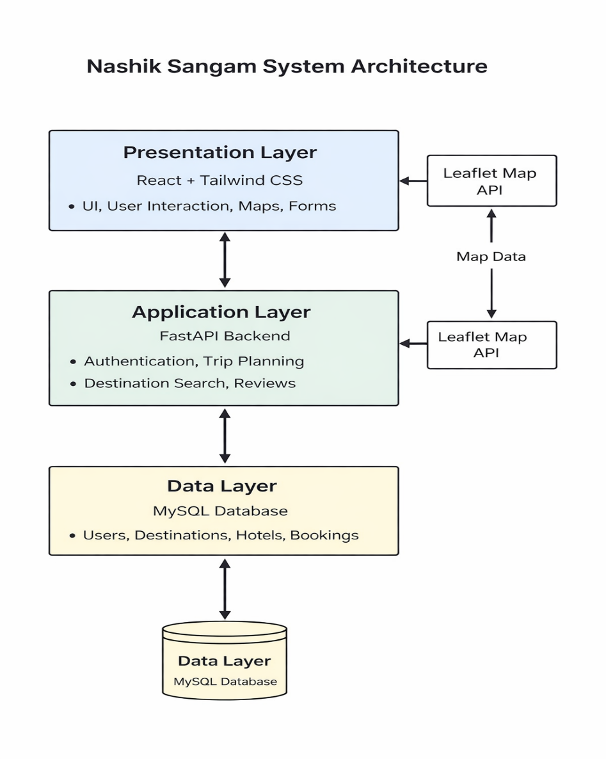

Fig. 5.1 System Architecture

5.2.2 Zero Level DFD Diagram

Data Flow Diagrams show the flow of data from external entities into the system and between processes within the system. There are four symbols for drawing a DFD: open-ended rectangles or a disk symbol representing data stores, processes as rounded rectangles, external entities as squares, and arrows representing data flow.
Each process is first shown as a Context Level DFD and later as a Detailed DFD. The Context Level DFD provides a conceptual view of the process and its surrounding input, output, and data stores. The Zero Level DFD shows the high-level data movement in the system.

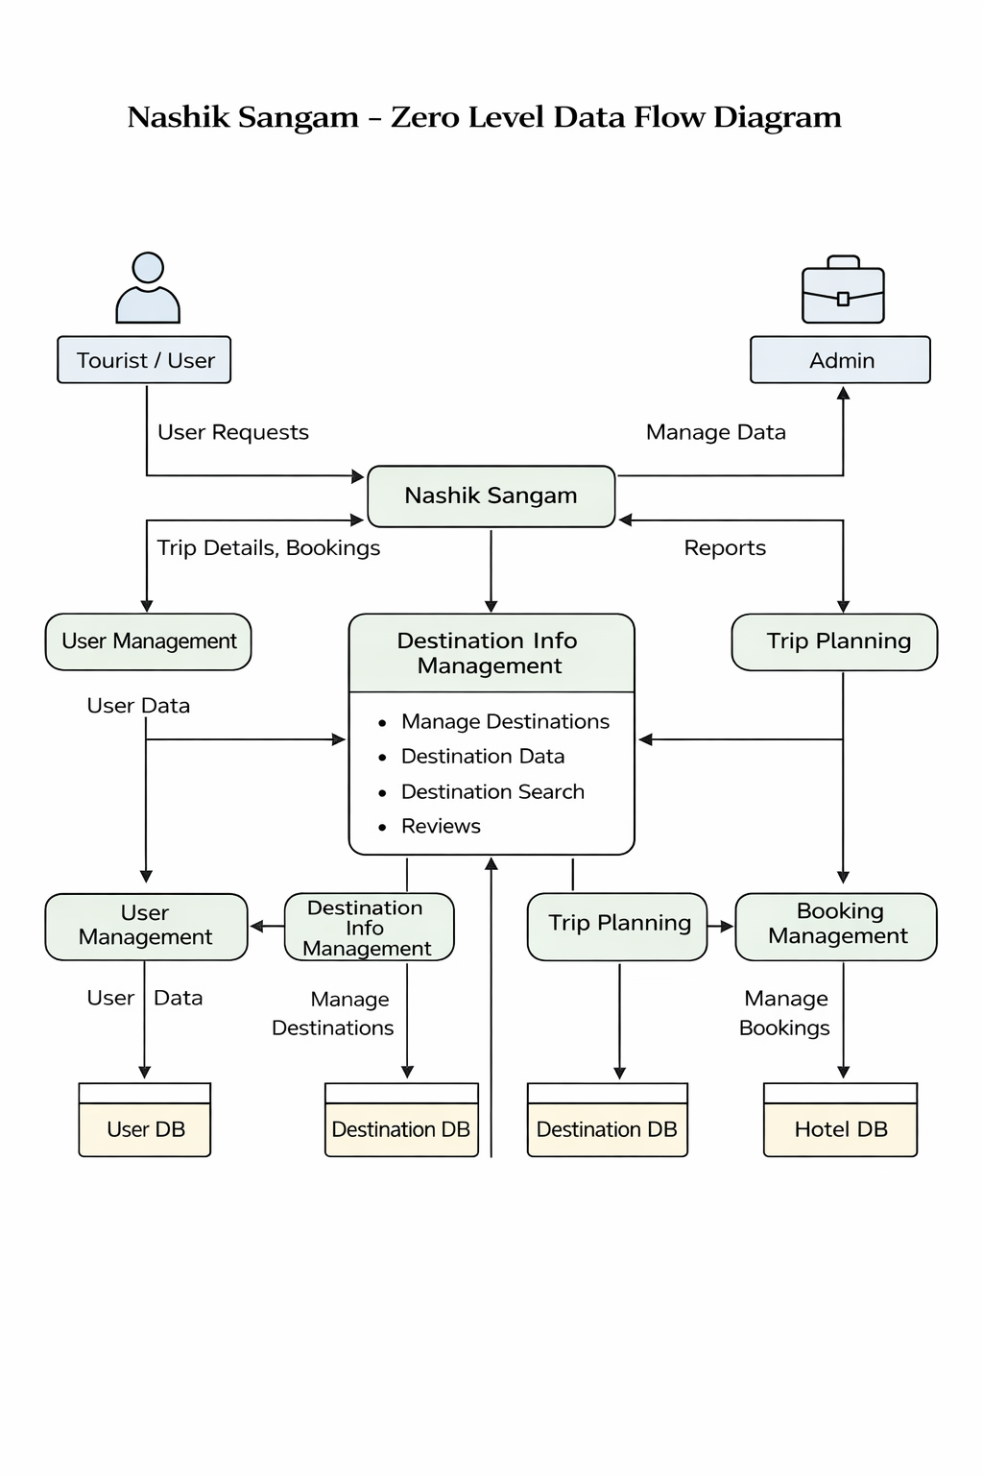
Fig. 5.2 Zero Level DFD

5.2.3 Context Level DFD Diagram

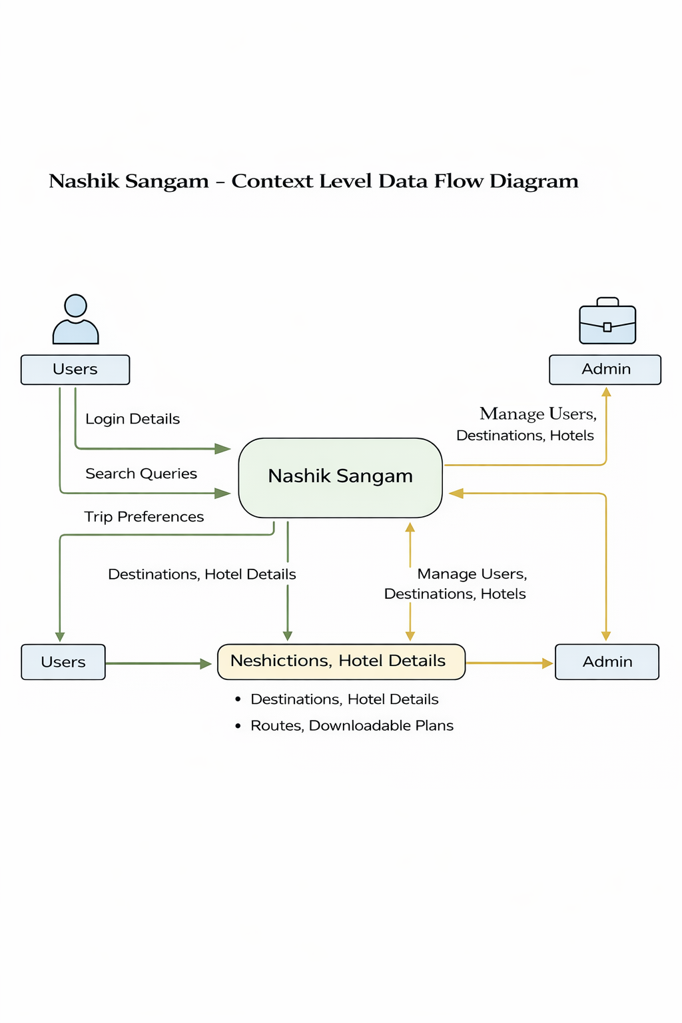
Fig. 5.3 Context Level DFD

5.2.4 Class Diagram

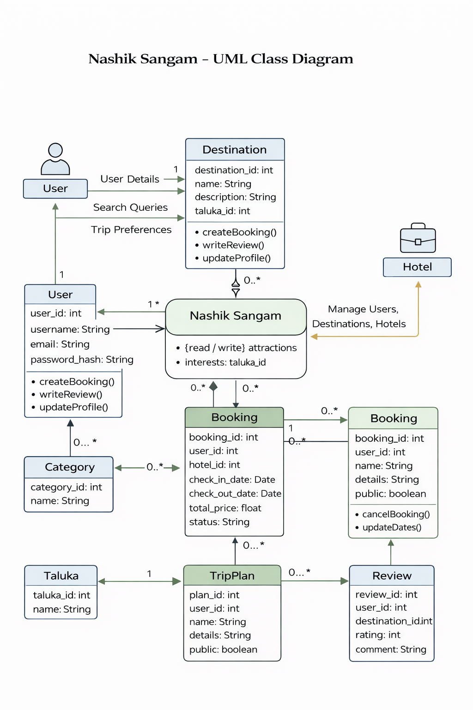

Fig. 5.4 Class Diagram

5.2.5 Activity Diagram

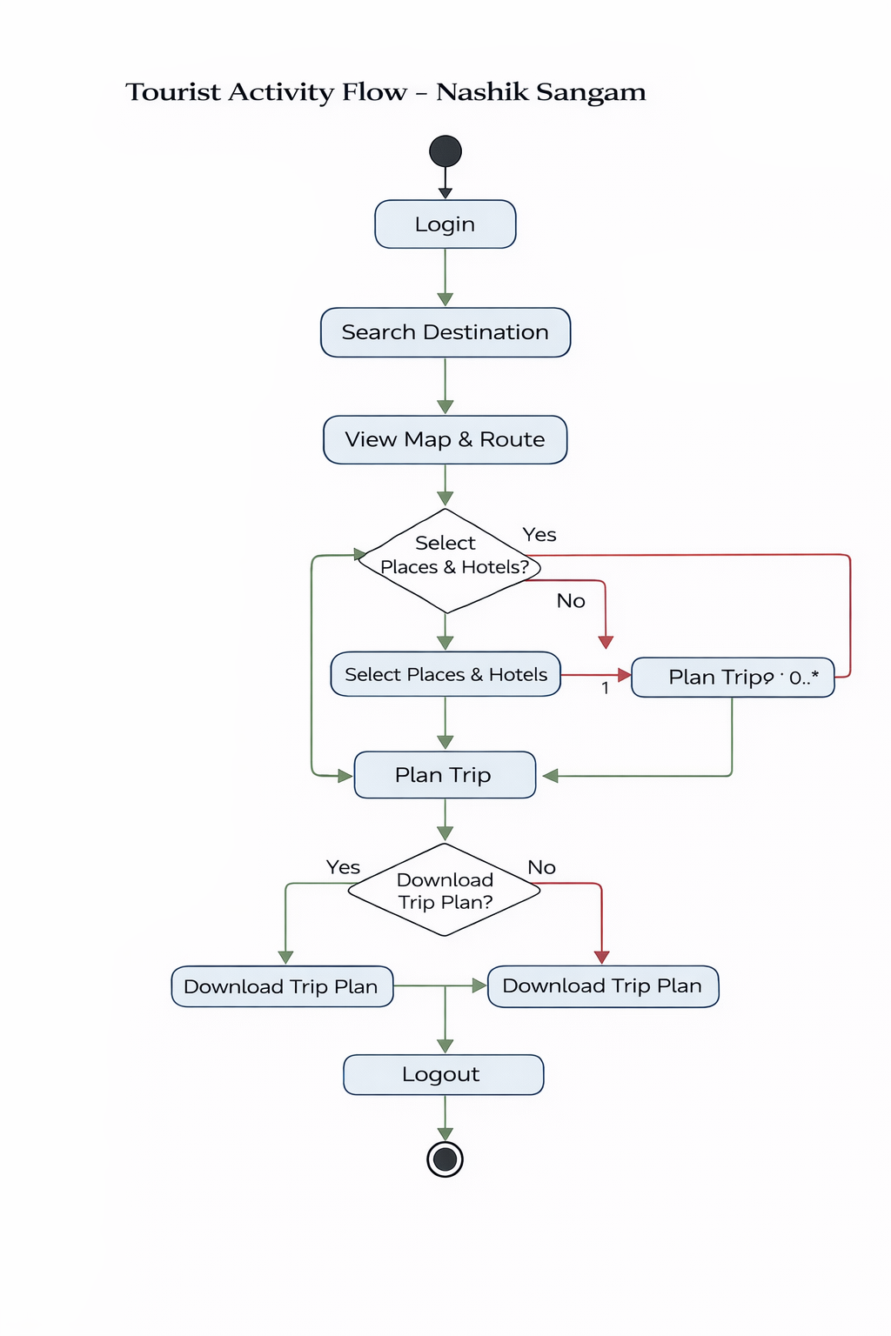

Fig. 5.5 Activity Diagram

5.2.6 Sequence Diagram

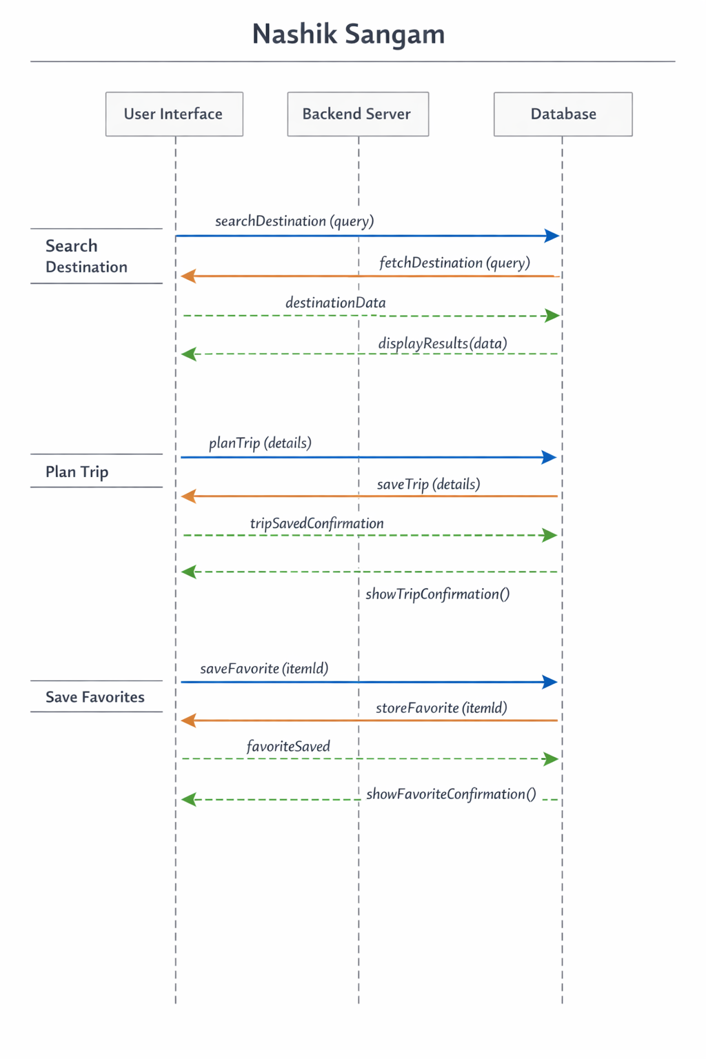

Fig. 5.6 Sequence Diagram

5.2.7 Component Diagram

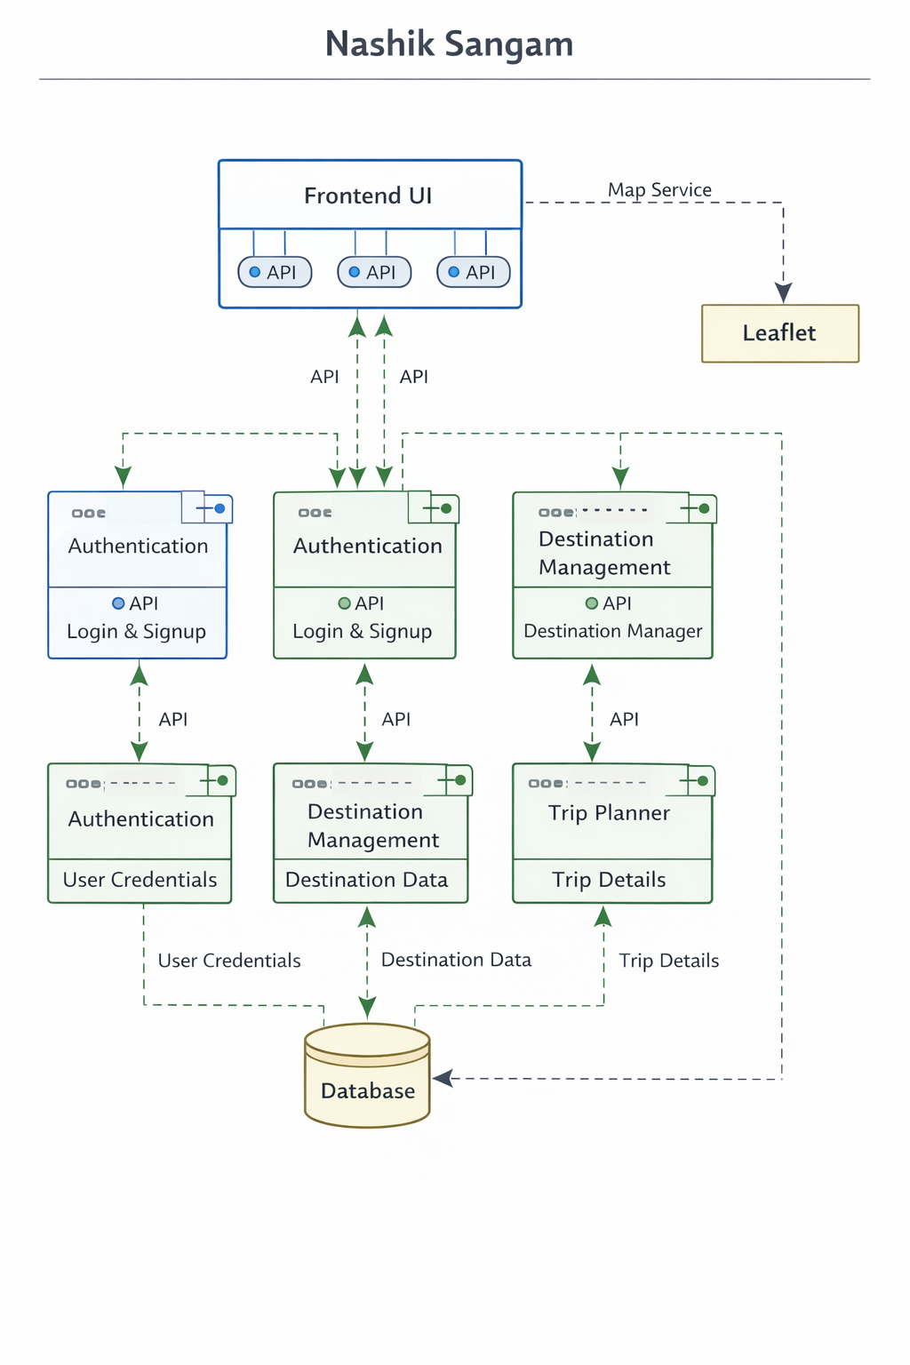

Fig. 5.7 Component Diagram

5.2.8 Deployment Diagram

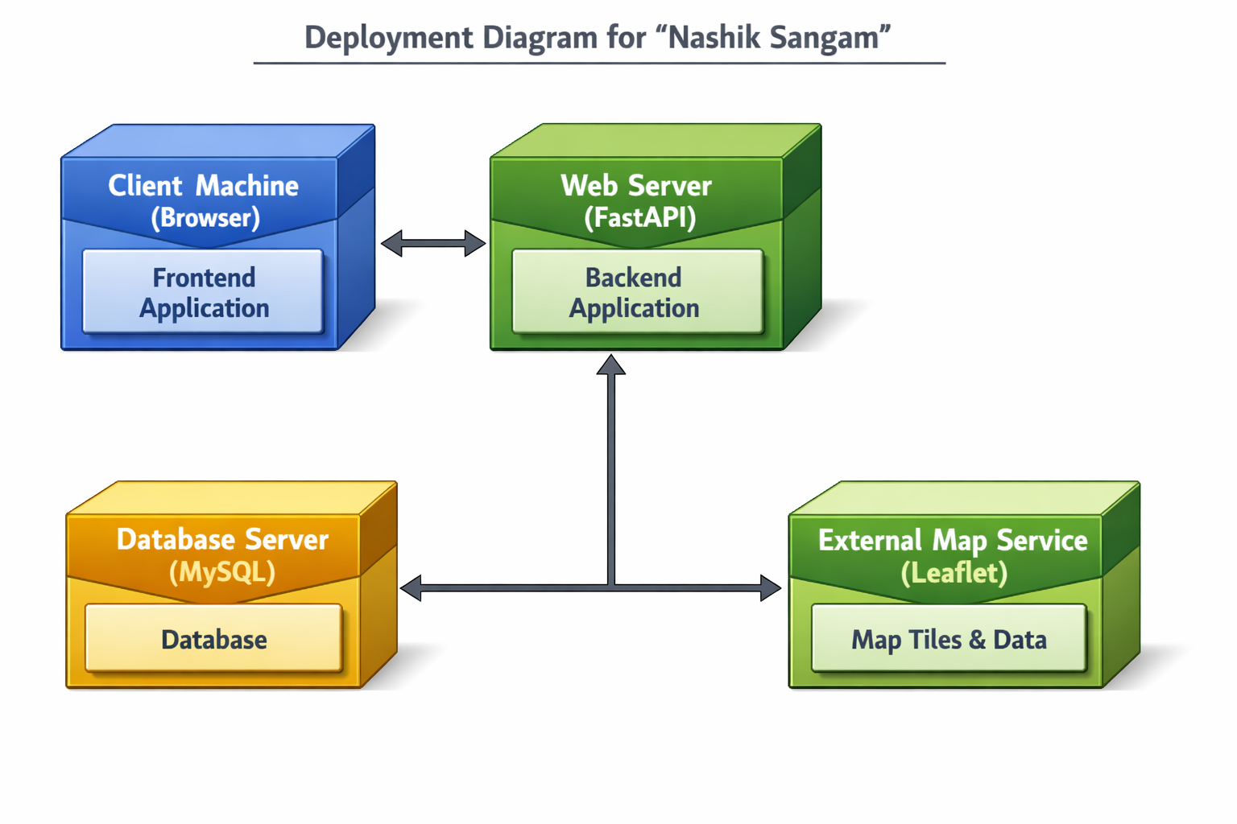

Fig. 5.8 Deployment Diagram

5.2.9 Use-Case Diagram

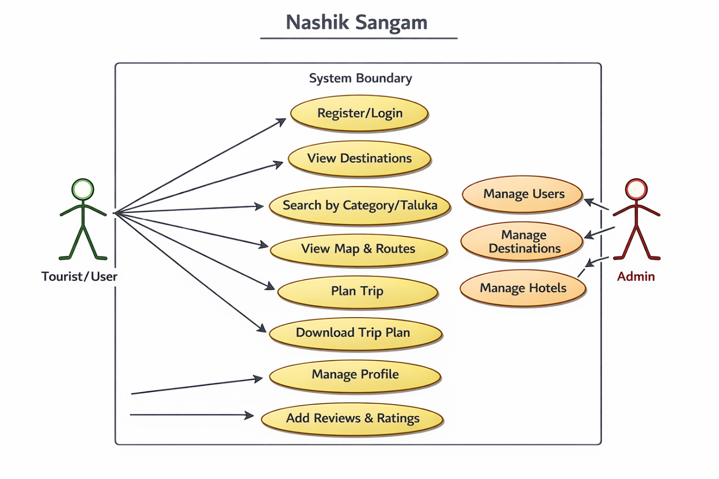
Fig. 5.2.9 Use-Case Diagram

CHAPTER 6: RESULT

CHAPTER 7: SYSTEM REQUIREMENT

7.1 Software Requirements

The following software tools and technologies are required for the successful development and execution of the project “Nashik Sangam”:

- Operating System:
Windows 10 / Windows 11 (64-bit)

- Frontend Technologies:
React.js
Tailwind CSS
HTML5, CSS3, JavaScript

- Backend Technologies:
Python
FastAPI Framework

- Database:
MySQL
MySQL Workbench

- Development Environment / IDE:
Visual Studio Code (VS Code)

7.2 Hardware Requirements

The minimum hardware configuration required to develop and run the system efficiently is as follows:

- Processor:
Intel Core i5 or equivalent

- RAM:
8 GB

- Hard Disk:
Minimum 20 GB free storage

- Input Devices:
Keyboard, Mouse

7.3 Project Plan
The project was completed over a period of 2 months, starting from 25th November and ending on 15th January.
The development process was divided into well-defined phases to ensure systematic progress.

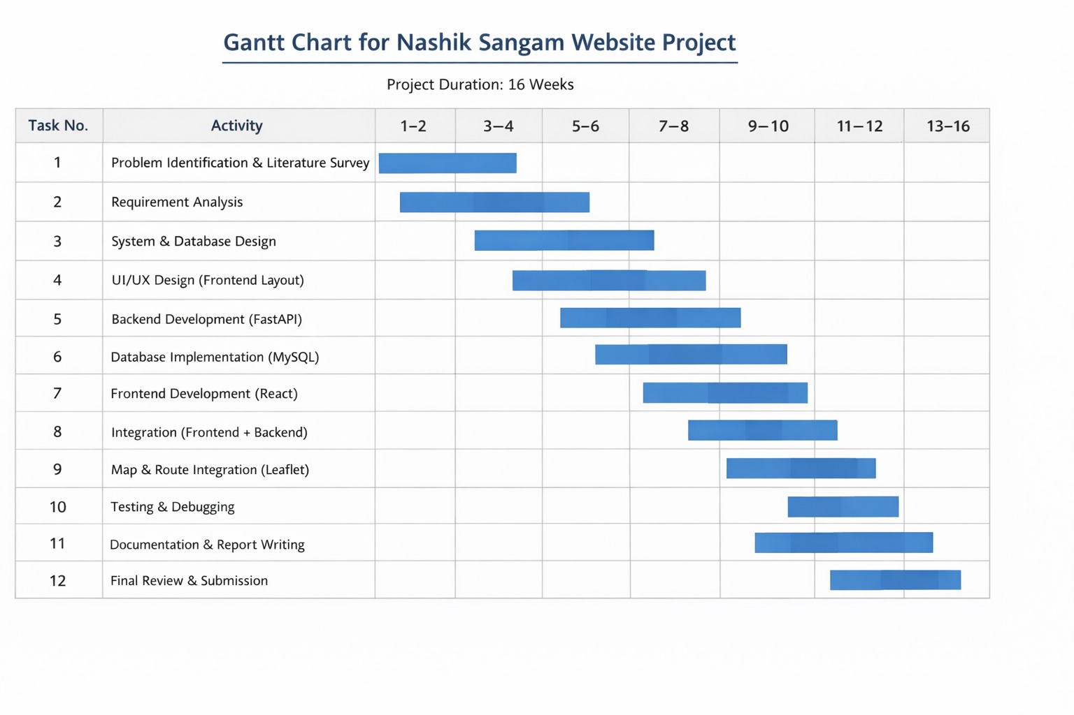
CHAPTER 8: CONCLUSION, LIMITATION AND FUTURE SCOPE

8.1 Conclusion
The Nashik Sangam tourism website has been designed in such a way that future modifications and enhancements can be carried out easily. The system successfully fulfills the objectives defined at the beginning of the project. The following conclusions can be drawn from the development of this project:
• Automation of the tourism information system improves overall efficiency and reduces manual effort.
• The system provides a user-friendly graphical interface, which is more effective and convenient compared to the traditional manual tourism information systems.
• Proper authentication and role-based access ensure that authorized users can access system features according to their permissions.
• The system minimizes delays in communication by providing real-time access to destination, hotel, and route information.
• Updating and managing tourism data becomes easy and systematic for administrators.
• System security, data integrity, and reliability are the key strengths of the application.
• The modular design of the system allows easy scalability and future enhancements such as reviews, online bookings, and recommendation systems.

8.2 Limitations
Despite its advantages, the system has certain limitations:
• The system requires an active internet connection to access maps, routes, and real-time data.
• The accuracy of routes and locations depends on third-party map services.
• Advanced features such as live hotel availability and online payment are not included in the current version.

8.3 Project Costing
The estimated cost of development for the Nashik Sangam tourism website is shown below. Since the project is developed as an academic project, many costs are assumed or minimized.

Description | Cost (Rs.)
Developer’s Time (Approx. 150 Hours – Student Effort) | 4,500
Hosting and Server Setup (Localhost / Free Tier) | 1,500
Backend & API Development | 0
Frontend Development (React UI Design) | 0
Database Design & Implementation (MySQL) | 0
Map & Route Integration (Leaflet – Open Source) | 0
Testing and Quality Assurance | 0
Documentation and User Manual | 1000
Total Estimated Project Cost | 7000 Rs.

8.4 Future Scope
The Nashik Sangam tourism system has significant potential for future enhancements. The current system provides a strong foundation on which advanced features can be implemented. The following improvements can be considered in future versions of the system:
• Advanced AI-Based Destination Matching:
Artificial Intelligence techniques can be used to recommend tourist destinations based on user preferences, travel history, budget, and time constraints, thereby improving personalized travel planning.
• Skill Development and Tourism Awareness Resources:
The platform can be extended to include informational resources for local guides, tourism students, and service providers, helping them enhance skills related to hospitality, local culture, and tourism management.
• Real-Time Chatbot for User Communication:
A real-time chatbot can be integrated to assist tourists with queries related to destinations, routes, hotels, and travel planning, reducing dependency on manual support.
• AI Chatbot Support:
An intelligent AI-powered chatbot can be developed using Natural Language Processing (NLP) to provide accurate and context-aware responses, improving user engagement and support efficiency.
• Client Review and Rating System:
A review and rating module can be added to allow users to share feedback on destinations and hotels, helping other tourists make informed decisions and improving service quality.
• Multilingual Support:
To support a diverse user base, the system can be enhanced with multilingual interfaces, enabling tourists from different regions to access information in their preferred language.

CHAPTER 9: APPENDIX

- XML – Extensible Markup Language
- E-R – Entity Relationship
- DFD – Data Flow Diagram
- UI – User Interface
- API – Application Programming Interface
- DBMS – Database Management System
- UML – Unified Modeling Language
- CRUD – Create, Read, Update, Delete
- GIS – Geographic Information System
- NLP – Natural Language Processing

CHAPTER 10: REFERENCES & BIBLIOGRAPHY

- The Unified Modeling Language Reference Manual – James Rumbaugh, Ivar Jacobson, Grady Booch, Addison-Wesley.
- Database Management Systems – Raghu Ramakrishnan, Johannes Gehrke, McGraw-Hill Education.
- Software Engineering – K. K. Aggarwal, Yogesh Singh, New Age International Publishers.
- Web Technologies – Uttam K. Roy, Oxford University Press.
- React Official Documentation – Available at: https://react.dev
- FastAPI Documentation – Available at: https://fastapi.tiangolo.com
- MySQL Reference Manual – Oracle Corporation, Available at: https://dev.mysql.com/doc/
- Leaflet JavaScript Library Documentation – Available at: https://leafletjs.com
- Tourism Information Systems: Design and Implementation – International Journal of Tourism Research.
- Smart Tourism Systems Using Web Technologies – IEEE Xplore Digital Library.

CHAPTER 11: CERTIFICATE

